Homework # 1

Ruchi Panwar(rpanwar@kent.edu)

Software Testing

Fall 2015

Professor: Dr. Gregory S DeLozier

Sept 11, 2015

**1**. Get Python set up on your computer.

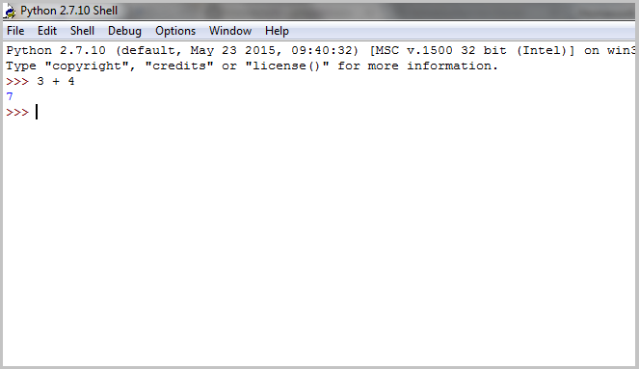

**2**. Get your PythonAnywhere account set up.

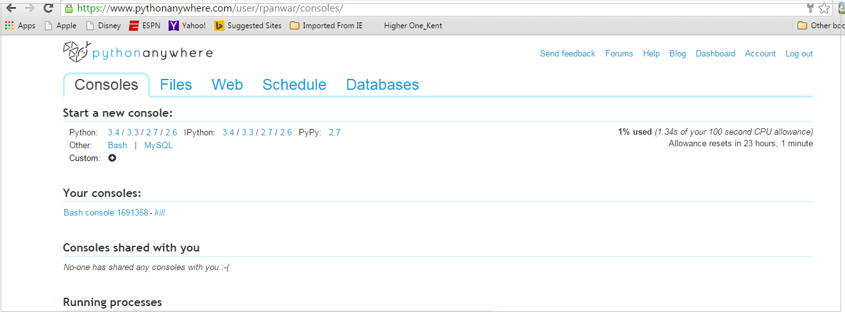

PythonAnywhere Link - <https://www.pythonanywhere.com/user/rpanwar/consoles/>

**3**. Get the examples from class (calc.py, add.py) running on your computer and on PythonAnywhere (PA)

3.1 add.py (Visual Studio)

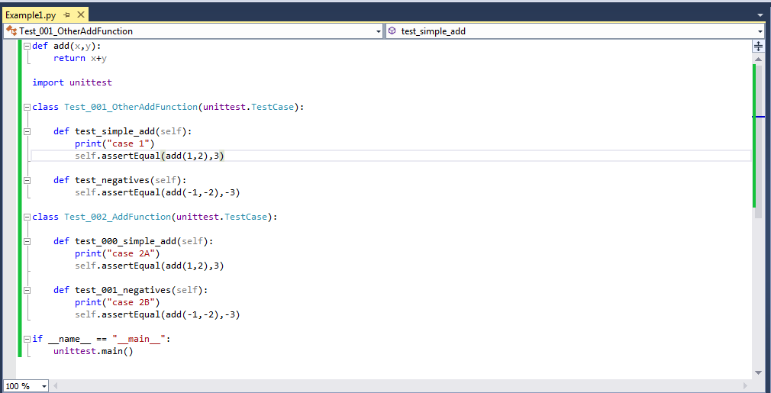

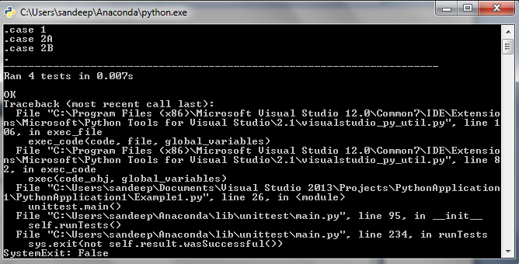

3.2 add.py (PythonAnywhere)

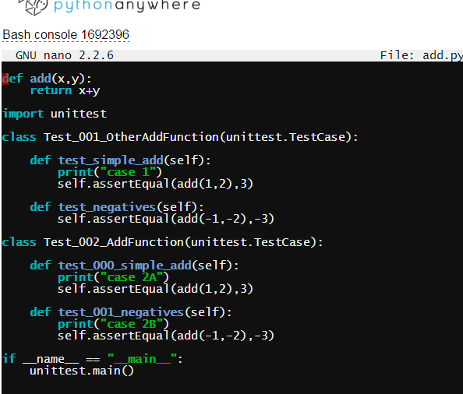

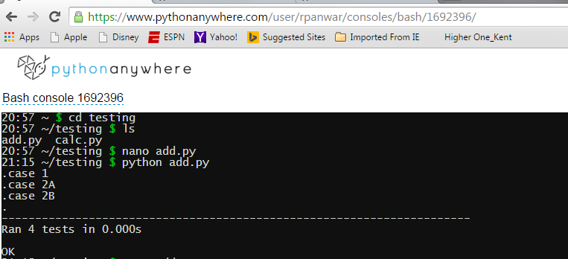

3.3 clac.py (Visual Studio)

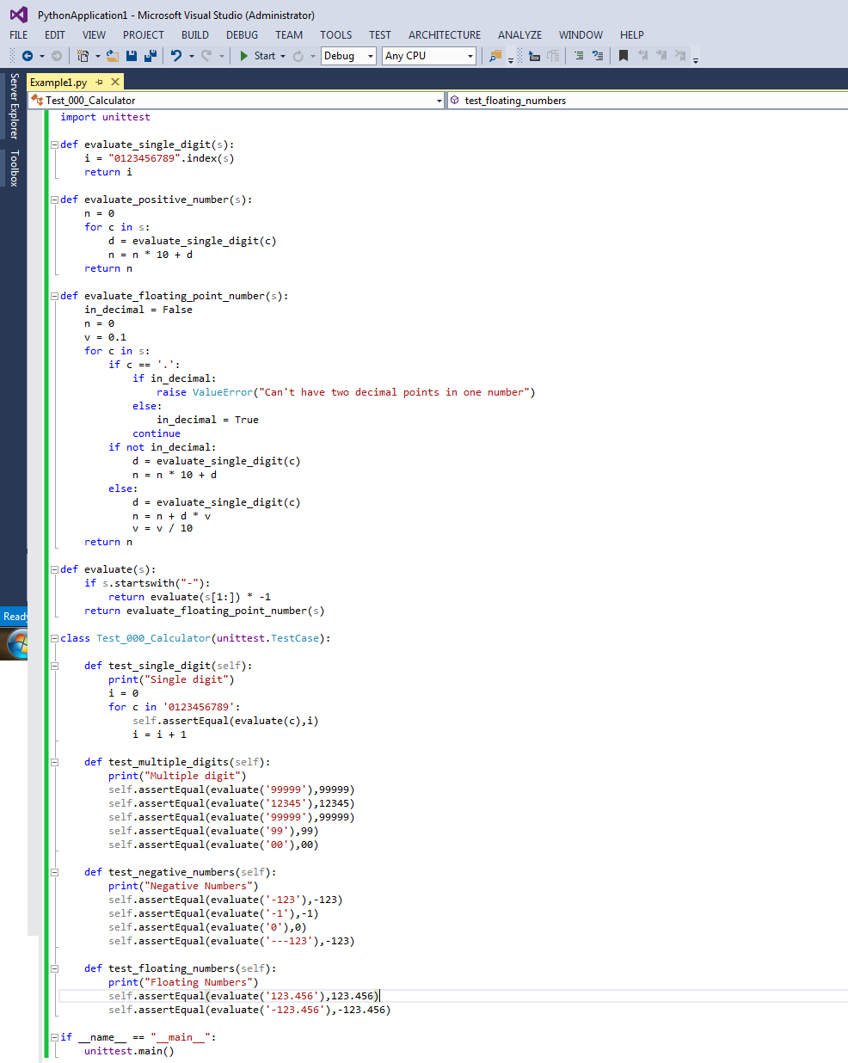

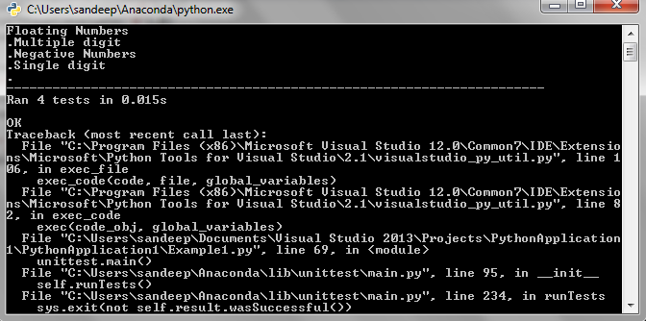

3.4 calc.py (PythonAnywhere)

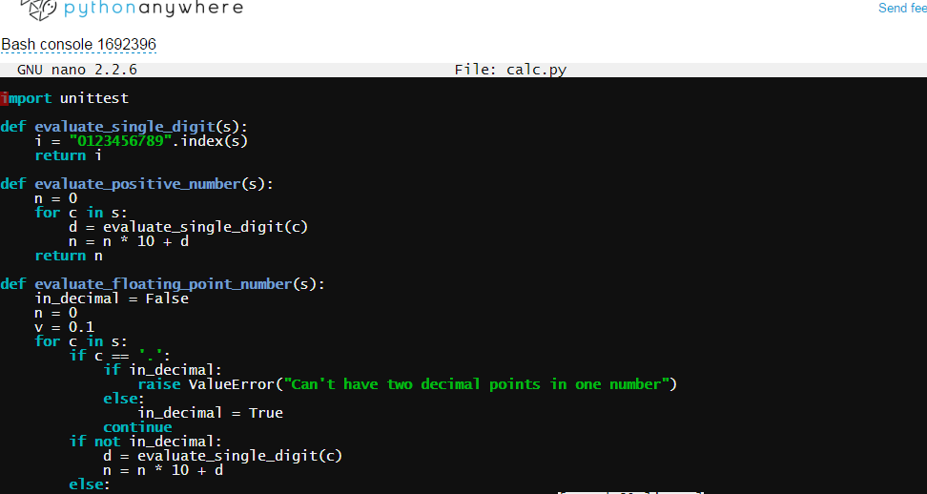

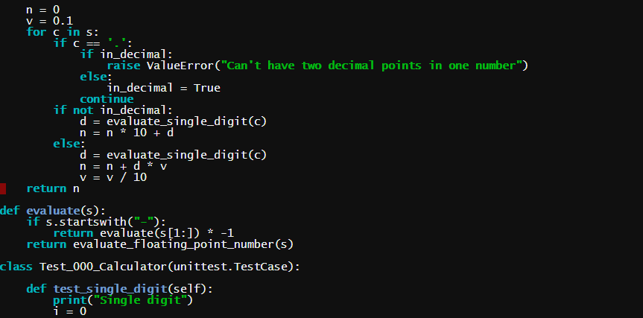

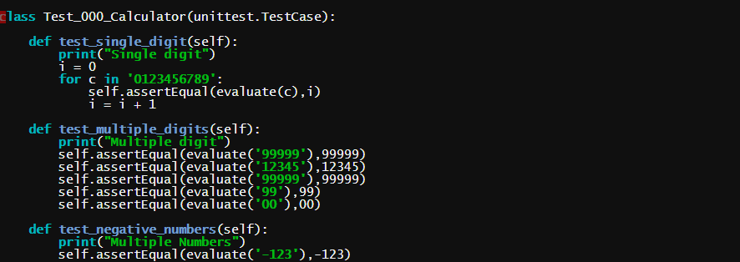

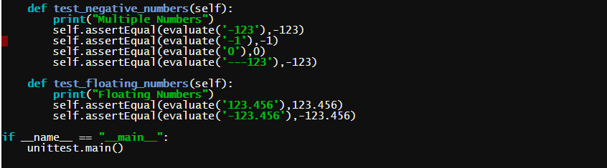

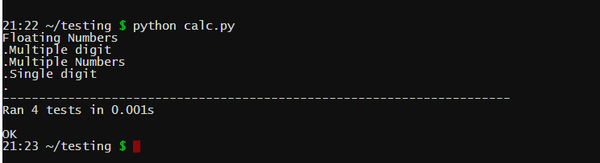

**4**. Add one feature to calc.py using Test Driven Development - Hexadecimal Numbers

Hexadecimal String :

